**The Effect Of Adding In A Bike Per Day And The Highest Active User Count**

By: Mayank Sharma

Michael Teixeira

New York City is one of the most densely populated cities in the world. With a staggering population of 8 million people, no wonder there’s an extra sixteen minutes of commute in the morning and an extra twenty-one minutes of commute in the evening for every thirty minutes of driving [1]. Although traffic may be a breaking point for some business owners, we, as the newly established WeBikeNewYork startup, want to capitalize on public transportation congestion. For us, more traffic means more business, but, before we get started, we want to learn a little more before scaling our business. Here’s what we’re interested in learning; if we increase the number of bikes we make at a rate of one bike per day over a thirty day period and supply them to our consumers, will we see the number of active bike users grow? This will give us a rough estimate as to how many bikes should be produced before over-production occurs and we lose money.

Our company, WeBikeNewYork, has been able to gather New York traffic data from 2019 to help simulate a real-world model for our problem statement. The data is broken down into each day of the week and the hour of that day. Each hour contains a percentage of facing traffic.This allows us to see how overcrowded traffic can be at various points throughout the week. Using an example from our gathered data, Friday between 5:00 pm and 6:00 pm was the day and hour with the highest chance to face traffic [2]. We can also interpret the data as an indication that more people commute on certain days and times than others. We used these probabilities to enhance our model to the real world in the likelihood that someone will ride our bikes. Building on our Friday example, this now turns into a 76% chance that someone will be riding our bike between 5:00 pm and 6:00 pm. Additionally, as each day goes by, we add a new bike to our simulation for up to thirty days. We hypothesize that by adding in more bikes, we’ll have a steady incline of more active users. We believe this to be the case because over a period of time, one location may have the majority of the bikes. This causes the other location to be unable to provide bikes to its own customers. By adding in a bike at a rate of one per day, we minimize the chance of a location experiencing a drought in users using a bike.

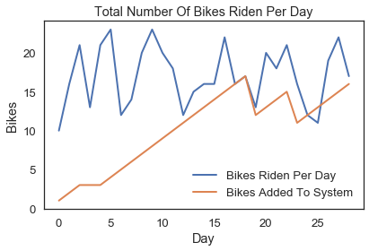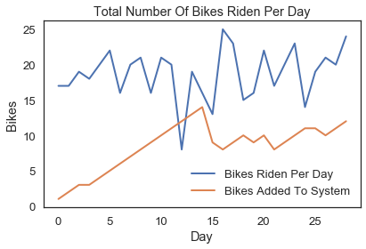

The above charts display two of the results of the various simulations that we ran. The y-axis represents the number of bikes and the x-axis represents the day in that simulation. The blue line represents the total number of bikes ridden for the day and the orange line represents the number of bikes added to our system. As the number of bikes added to our system increased, the number of active users per day stayed relatively the same.

Our team at WeBikeNewYork had hypothesized that by adding bikes to our system, at a rate of one bike per day, we would have a steady incline of more active users. From our simulation, we concluded that our hypothesis was wrong. The inclusion of new bikes into our system does not always guarantee more active users because there are certain days and times throughout the week in which user activity is greater due to a higher probability of traffic. We believe that our model simulates a short period of time fairly well due to the constraint of thirty-days. If our simulation scaled to more than thirty-days, the results would not be relevant. One reason why our results would not be accurate is due to the limitation of only reaching a max of twenty-four active users on a given day. Although we would have plenty of free bikes in our system, the majority of them would be idle because of the insufficient amount of customers capable of riding our bikes per day. We are only limited to twenty-four customers per day because there are twenty-four hours in a day. Therefore, we would need to introduce a new variable to increase the quantity of potential customers in our system. Another improvement that could be made is to only add a bike to our system when a customer needs one. This prevents us from having an excess amount of bikes, keeping our inventory close to the customer population. Implementing these two solutions would allow us to scale our product and compete in the busy New York Public Transporation market.

1. https://www.tomtom.com/en_gb/traffic-index/new-york-traffic
2. Tomtom-TrafficIndex